



Canadian Technical Report of

Fisheries and Aquatic Sciences XXXX

2021

Historical Summary of Sampling Station Relocations in the Annual southern Gulf of Saint Lawrence Snow Crab Survey

By

Tobie J. Surette

Fisheries and Oceans Canada

Science Branch

Crustaceans Section

343 Université Avenue

Moncton, NB

E1C 9B6

© Her Majesty the Queen in Right of Canada, 2021

Cat. No. Fs 97-6/XXXXE-PDF ISBN XXX-X-XXX-XXXXX-X ISSN 1488-5379

Correct citation for this publication:

Surette, T. J. 2021. Historical Summary of Sampling Station Relocations in the Annual southern Gulf of Saint Lawrence Snow Crab Survey. Can. Tech. Rep. Fish. Aquat. Sci. XXXX: v + XX p.

**CONTENTS**

**ABSTRACT** iv

**RÉSUMÉ** iv

**CONTEXT** 1

**DESCRIPTION** 1

**ANALYSIS** 2

**CONCLUSION** 3

**REFERENCES** 4

**TABLES** 5

**FIGURES** 7

# **ABSTRACT**

Surette, T. J. 2021. Overview of the Snow Crab Survey Station Relocations in the southern Gulf of Saint Lawrence. Can. Tech. Rep. Fish. Aquat. Sci. XXXX: v + XX p.

An annual trawl survey forms the basis of stock assessment and management of the lucrative quota-based snow crab fishery in southern Gulf of Saint Lawrence. This survey has undergone a number of redesigns from its beginnings in 1988, with the most recent being in 2013. We quantify the number of sampling stations which were added over the history of the survey. From 2013 to 2020, we show that the practice of relocating sampling stations in response to serious trawl damage has shrunk the original set of 355 random stations of 2013, down to 186 stations in 2020, with the remaining 169 stations having been relocated one or more times over the period. A comparison of snow crab density trends between areas of the survey which containing relocations versus those which have remained fixed shows some signs of relative increase among the set of relocated samples, suggesting possible increase in survey catchability for certain groups of snow crab.

# **RÉSUMÉ**

Le relevé au chalut du crabe des neiges dans le sud du Golfe du Saint-Laurent est l’outil principal du processus d’évaluation du stock et de la gestion de cette pêche lucrative et règlementée par quotas. Le plan d’échantillonnage a subi plusieurs remaniements depuis ses débuts en 1988, le dernier a eu lieu en 2013. Nous avons examiné l’historique du relevé et quantifié l’ajout et les déplacements des stations d’échantillonnages au fil des années. De 2013 à 2020, la pratique de relocaliser les stations d’échantillonnages quand le chalut subissait trop de dommage a réduit progressivement le nombre de stations conformes aux 355 stations aléatoires originales. En 2020, seulement 186 stations sont demeurées fidèles à leur emplacement original tandis que 169 stations ont été relocalisées au moins une fois. Une analyse a révélé que la proportion des captures représentée dans les stations ayant été déplacées de 2013 à 2020 a augmenté pour les petits crabes recrues et les crabes commerciaux, toutefois celle des femelles matures est demeurée stable.

Surette, T. J. 2021. Overview of the Snow Crab Survey Station Relocations in the southern Gulf of Saint Lawrence. Can. Tech. Rep. Fish. Aquat. Sci. XXXX: v + XX p.

# **CONTEXT**

The southern Gulf of Saint Lawrence snow crab annual survey has a 34-year history, from initial exploratory surveys in 1987 and 1988 up to the present. These provide fishery-independent data that are used to calculate biomass indices, which in turn are used to set annual quotas for the lucrative fishery. Over this period, the survey has undergone many changes, including expansions of the survey area and spatial sampling design, survey vessel changes, as well as the addition of new measurement devices and probes to improve data quality and catch standardization.

Some of these changes have been highlighted as possible sources of bias when comparing annual abundance and biomass indices that form the basis of the management of this stock. In particular, a stock assessment review process in 2020 (Hébert et al, 2021) highlighted that the current practice of relocating survey sampling stations when encountering trawl damage (e.g. tear-ups) may lead to stations being progressively displaced to more trawlable sea bottoms as stations are repeatedly moved over time. Consequently, sampling more trawlable areas may lead to biases in survey catches, as the location of sampling stations deviate from to the random spatial sampling design.

We present here a historical summary of which survey stations were revisited or relocated from year to year. Other details on the sampling protocol and the historical development of this survey can be found in Moriyasu et al. 2008 and Hébert et al. 2021.

# **DESCRIPTION**

The spatial sampling design for the snow crab survey is based on fixed sampling stations whose locations are randomly generated within a regular grid overlaying the survey area. Rectangular 10’x10’ grids were used from 1988 to 2011. However, being based on latitude-longitude, the shape of these grids were rectangular and, moreover, varied by ~5% in surface area with from north to south of the survey area. From 2012 onwards, a square grid spatial sampling design was used. Although large subsets of sampling stations were fixed (i.e. resampled) from year to year, new sampling stations were continually added through survey expansions, relocation of sampling stations from difficult to more favourable trawling locations, as well as in response to significant changes in spatial sampling design in 1991, 2006, and in 2012 and 2013 (Table 1).

The entire set of survey sampling station locations were numbered according to their chronological order of appearance. Though specific tow locations may show small variation from year to year, tows were deemed as belonging to the same sampling station if their center points were within 1.5 km of each other. Using this definition, about 2000 different sampling stations were identified from the 1988 to 2020 surveys. Figure 1 shows the order of appearance of these stations as well as the frequency of their recurrence in subsequent surveys.

From an initial set of locations in 1988, new stations were added or redistributed over most years of the survey. In particular, earlier surveys saw many sampling stations added as the survey area expanded from 1988 to 1993. Only a partial survey was conducted in 1996 due to funding lack of funding. The period from 1994 to 2005 saw progressively smaller proportions of stations being added or re-located, in part due to technological improvements in geolocation plus a general tendency to relocate stations from difficult trawling areas to more suitable to trawling areas within each sampling grid.

A large portion of new sampling stations accompanied a survey sampling redesign in 2006, which sought to more uniformly distribute stations within the survey area, as some sampling grids had accrued more stations than others in previous years. The 2006 set of sampling stations were sampled to a high degree of fidelity from 2006 to 2011.

Following the sampling design change in 2012, a completely new set of 325 survey stations were generated in 2012. This process was then repeated for 355 stations in 2013. Fishing at new set of random stations led to relatively high rates of trawl damage and tow rejections from 2012 and 2013, relative to other years.Figure 2 shows the proportion of failed tows for 2007 to 2019. In particular ~17% and ~20% of attempted tows failed on their first attempt for 2012 and 2013, respectively. Given that the spatial sampling density over the survey area is fairly uniform, these proportions are good estimates of the trawlable proportion of the current survey area. In comparison, tow rejection rates in 2006 -2011 were lower at ~10%.

The survey protocol from 2013 onward reverted to an earlier practice, used prior to 2006, of relocating sampling stations to alternate locations when serious trawl damage occurred. This was accompanied by a general reduction of tow rejection rates from a high of 14.5% in 2015 down to ~10% in 2017-2019.

We selected the most recent survey design implementation of the survey, the series from 2013 to 2020, which had a fixed survey area and a fixed sampling scheme of 355 survey grids. By design, each grid contains a single sampling stations. In 2013, a random set of survey stations within each grid was generated. Though many of this original set of stations have remained fixed up to 2020, many have been relocated through the process of moving to alternate random stations when serious trawl damage occurred. For each survey grid (n = 355), we tabulated the number of times a survey station had been relocated for each year over time.

Figure 3 shows the specific locations where major trawl damage occurs in the survey, indicating that problematic areas lie mainly along the north shore of Prince Edward Island, immediately West of Shediac Valley, and along the edge of the Laurentian Channel. Figure 4 shows the total number of times survey stations have been relocated within each survey grid from 2013 to 2019.

Table 2 shows a detailed breakdown of the number of survey grids, out of a total 355, which have undergone a specified number of sampling station relocations, between the 2013 and 2020 surveys. In particular, 67 stations from the original set of 355 random stations in were moved to alternates in 2013. Progressively more and more grids contained relocated stations, though the number of original stations being moved has decreased to about 11 per annum in the past 4 years. In 2020, only 186 from the original 2013 stations remained fixed, with 80 of the remaining stations moving once, 33 moving twice, 29 moving three times, and 27 moving four or more times.

# **ANALYSIS**

We sought to see whether the gradual displacement of trawl stations in certain areas to more trawlable bottom led to relative increases in snow crab abundance among the set of grids whose stations had been displaced over the period from 2013 to 2020.

To perform the analysis, we separated the set of 355 survey grids used in the 2013 to 2020 survey into two groups: those whose stations had remained fixed over the period, and those whose stations had been relocated one or more times in 2020. Removed from the analyses were the 69 grids which already contained an alternate station in 2013. Average annual densities were calculated for each group, and the ratio between the  relocated versus fixed set of grids was calculated. Four variables were selected for analysis: male and female instar VIII, mature females and commercial male recruits.

For male and female instar VIII, the ratio (moved/fixed) gradually increased remained relatively stable at ~50-60% from 2013 to 2015, with the ratio increasing for males in 2016 and again in 2017, and increasing in 2017 for females. The ratio then increased to very high levels above parity in 2018 and 2020 for both sexes, with a lower level in 2019 which was comparable to the 2017 levels of ~70-80%. For commercial recruits, the increase was more gradual, shifting from a ratio of ~50% to ~80% for 2017-2020. In contrast, the ratio for mature females was more stable, remaining between 50% and 65%, with no overall trend over the period.

The shifts observed for instar VIII and commercial recruits described above lends some support to the hypothesis that survey sampling bias may be increasing in conjunction with the increasing proportion of survey stations on trawlable bottoms. However, mature females do not show a similar shift. Scale differences in some natural processes between the two survey grid sets, such as recruitment, migration, may also be driving the observed trends in the ratios. In addition, the spatial distribution of grids with fixed stations is not random (Figures 3 & 4), reflecting areas of known trawlability, thus may be more subject to local effects.

# **CONCLUSION**

Almost half of survey stations have been moved at least once since 2013. Although the relocated station are chosen randomly within their respective grids, stations over time will naturally gravitate towards locales with lower probability of trawl damage. Thus, as stations locations settle onto more trawlable bottom, the probability of trawl damage will tend to decrease over time, as was the case over the period from 2013 to 2020. A similar decrease is observed for the period preceding the 2006 survey.

Different types of sea bottom reflect different habitats and likely contain different crab densities and possibly trawl catchability. Increasing trends in relative abundance among grids containing station relocations suggest increasing catchability among instar VIII and commercial male snow crab, but similar a similar trend was not observed among mature females and such analyses are meant as exploratory as they are subject to confounding natural processes, such as recruitment and mortality, which may vary between the two sets of survey grids.

Relocating survey stations to alternates year after year weakens the original survey design of 2013, based on a set of random stations in a stratified grid designs. This exposes the survey to systematically increasing bias in cases where local crab densities or catchability vary with bottom trawlability.

To monitor the impact of survey station relocations over time on abundance and biomass estimates, it is recommended that a representative subset of the original 2013 set of random survey stations be chosen to remain fixed in subsequent surveys, while the remaining stations may be relocated as per the current protocol. This protocol change would allow for monitoring of drift between the two portions of the data as well as correcting catches if a problem is detected.

True fixed station sampling was used for this survey from 2006 to 2011, which maintained its entire set of designated sampling stations throughout, with a tow rejection rate of 10.8% overall. However, though this rejection rate may be deemed acceptable, we note that more than half of these survey stations were retained from the set used in 2005, which presumably had undergone the same station relocation process mentioned above.

Given that the tow rejection rate for 2013 was 20.7% and that of 2020 was 9.7%, we estimate that holding 50% of sampling stations as fixed will yield a rejection rate of ~15%. Smaller numbers of fixed stations will lower the rejection rate, but will lower the statistical power of the fixed stations as a control measure.

# **REFERENCES**

Hébert, M., Surette T., Landry, J.-F., and Moriyasu, M. 2021. [The 2020 assessment of snow crab, *Chionoecetes opilio*, stocks in the southern Gulf of St. Lawrence (Areas 12, 19, E and F).](http://www.dfo-mpo.gc.ca/csas-sccs/Publications/ResDocs-DocRech/2011/2011_082-eng.html) DFO Can. Sci. Advis. Sec. Res. Doc. 2021/0XX.

Moriyasu, M., Wade, E., Hébert, M. and Biron, M. 2008. Review of the survey and analytical protocols used for estimating abundance indices of southern Gulf of St. Lawrence snow crab from 1988 to 2006. DFO Can. Sci. Advis. Sec. Res. Doc. 2008/069.

# **TABLES**

Table 1. Survey vessel and sampling summary. Shaded areas represent blocks of similar survey designs from 2006 onwards.

|  |  |  |  |  |  |  |
| --- | --- | --- | --- | --- | --- | --- |
| **Year** | **Vessel** | **Horsepower** | **Survey grid** | **Stations** | **Sampling** | **Survey area(km2)** |
| 1988 | Emy Serge D. | 375 | 10'x10' | 152 |  | 29336 |
| 1989 | Emy Serge D. | 375 | 10'x10' | 155 |  | 29345 |
| 1990 | Emy Serge D. | 375 | 10'x10' | 162 |  | 29250 |
| 1991 | Emy Serge D. | 375 | 10'x10' | 177 | new stations | 29254 |
| 1992 | Emy Serge D. | 375 | 10'x10' | 233 |  | 29254 |
| 1993 | Emy Serge D. | 375 | 10'x10' | 208 |  | 29254 |
| 1994 | Emy Serge D. | 375 | 10'x10' | 259 |  | 29254 |
| 1995 | Emy Serge D. | 375 | 10'x10' | 261 |  | 29254 |
| 1996 | Emy Serge D. | 375 | 10'x10' | 72 | partial | 29254 |
| 1997 | Emy Serge D. | 375 | 10'x10' | 259 |  | 29254 |
| 1998 | Emy Serge D. | 375 | 10'x10' | 261 |  | 31696 |
| 1999 | Den C. Martin | 402 | 10'x10' | 277 |  | 35748 |
| 2000 | Den C. Martin | 402 | 10'x10' | 280 |  | 35748 |
| 2001 | Den C. Martin | 402 | 10'x10' | 292 |  | 35748 |
| 2002 | Den C. Martin | 402 | 10'x10' | 319 |  | 35748 |
| 2003 | Marco-Michel | 660 | 10'x10' | 317 |  | 37518 |
| 2004 | Marco-Michel | 660 | 10'x10' | 347 |  | 37518 |
| 2005 | Marco-Michel | 660 | 10'x10' | 355 |  | 37518 |
| 2006 | Marco-Michel | 660 | 10'x10' | 354 | new design | 44302 |
| 2007 | Marco-Michel | 660 | 10'x10' | 355 |  | 44302 |
| 2008 | Marco-Michel | 660 | 10'x10' | 355 |  | 44302 |
| 2009 | Marco-Michel | 660 | 10'x10' | 355 |  | 44302 |
| 2010 | Marco-Michel | 660 | 10'x10' | 354 |  | 44302 |
| 2011 | Marco-Michel | 660 | 10'x10' | 353 |  | 44302 |
| 2012 | Marco-Michel | 660 | 13.4 x 13.4 km | 321 | new design | 57840 |
| 2013 | Jean-Mathieu | 720 | 12.6 x 12.6 km | 352 | new stations | 57840 |
| 2014 | Jean-Mathieu | 720 | 12.6 x 12.6 km | 353 |  | 57840 |
| 2015 | Jean-Mathieu | 720 | 12.6 x 12.6 km | 353 |  | 57840 |
| 2016 | Jean-Mathieu | 720 | 12.6 x 12.6 km | 354 |  | 57840 |
| 2017 | Jean-Mathieu | 720 | 12.6 x 12.6 km | 353 |  | 57840 |
| 2018 | Jean-Mathieu | 720 | 12.6 x 12.6 km | 354 |  | 57840 |
| 2019 | Avalon Voyager II | 850 | 12.6 x 12.6 km | 352 |  | 57842.8 |
| 2020 | Avalon Voyager II | 850 | 12.6 x 12.6 km | 353 |  | 57842.8 |

Table 2. Frequency table showing the number of survey grids having undergone a specified number of survey stations relocations since the survey redesign of 2013.

|  |  |  |  |  |  |
| --- | --- | --- | --- | --- | --- |
| **Year** | **0** | **1** | **2** | **3** | **4+** |
| 2013 | 288 | 57 | 9 | 1 | 0 |
| 2014 | 261 | 75 | 13 | 6 | 0 |
| 2015 | 237 | 79 | 25 | 12 | 2 |
| 2016 | 226 | 77 | 28 | 16 | 8 |
| 2017 | 217 | 76 | 26 | 25 | 11 |
| 2018 | 206 | 76 | 30 | 29 | 14 |
| 2019 | 195 | 78 | 28 | 28 | 26 |
| 2020 | 186 | 80 | 33 | 29 | 27 |

# **FIGURES**

**Macintosh HD:Users:crustacean:Desktop:Stock-Assessment-2020:results:figures:english:survey:Survey Station History.pdf**

Figure 1. Historical cumulative summary of sampling stations added during the annual southern Gulf of Saint Lawrence snow crab survey. Shaded lines indicate that a station was successfully sampled for a particular year. The y-axis shows the order of appearance of sampling stations, with older sampling stations found near the bottom and the most recent stations near the top. Annotations show major changes in survey sampling design.

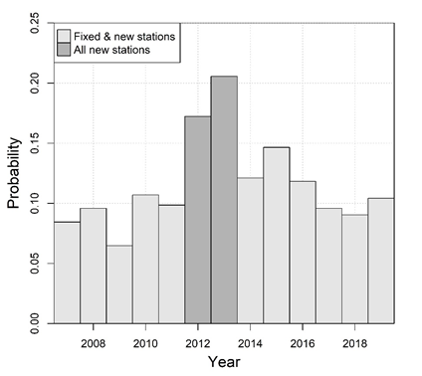

Figure 2. Proportion of tows rejected on the first attempt during the 2007 to 2019 snow crab surveys.

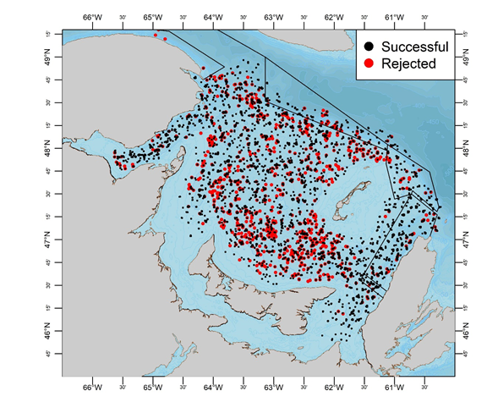

Figure 3. Locations of successful (black) and rejected (red) tows in the 2000 to 2019 snow crab surveys.

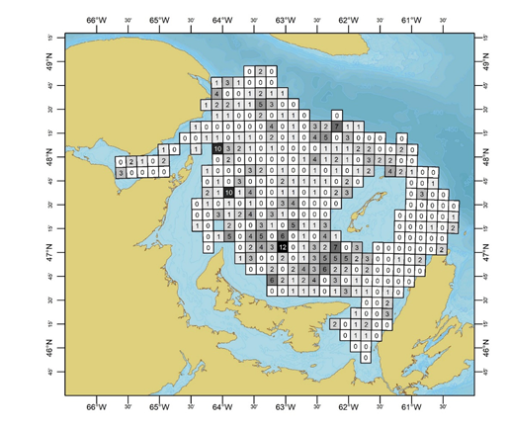

Figure 4. Map of survey sampling grids making up the current survey design, along with the total number of sampling station relocations which have occurred within them over survey years 2013-2019.

|  |  |
| --- | --- |
| **C:\Users\allainrn\AppData\Local\Microsoft\Windows\INetCache\Content.MSO\4B32039B.tmp** | **C:\Users\allainrn\AppData\Local\Microsoft\Windows\INetCache\Content.MSO\54517B61.tmp** |
| **C:\Users\allainrn\AppData\Local\Microsoft\Windows\INetCache\Content.MSO\A672B517.tmp** | **C:\Users\allainrn\AppData\Local\Microsoft\Windows\INetCache\Content.MSO\C8EF363D.tmp** |
| Figure 5. Ratio between densities of survey grids which contain survey stations which have moved over 2013 to 2020, over those whose stations have remained fixed, for four groups of snow crab: male instar VIII males (top left), females instar VIII (top right), mature females (bottom left) and commercial males (bottom right). | |